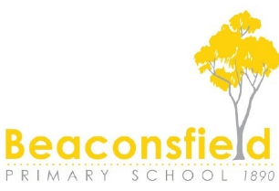
Beaconsfield Primary School 2024 Booklist Orders
www.booklistorders.com.au

You will need to register for a new account and reference your school specific code: BPS24 and verify your account by clicking the link in the email sent to you.
If you enter the wrong code, you will need to update the school code in the MyAccount section under the Edit My Details Section, School Information & then re click the link in the original email sent to you.
If you struggle with this, you can email the supplier: info@booklistorders.com.au and advise them which school you meant to sign up to. Or call 1300 855 085 Monday-Friday 9-5pm
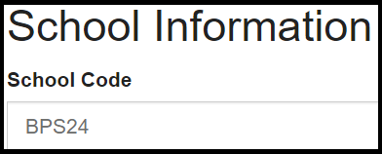
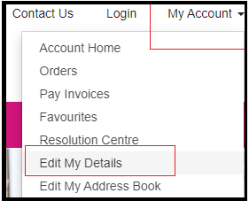
In an effort to keep pricing affordable, all orders will be fixed packs for 2024 with limited options to make changes.
Optional extras will be delivered in bulk to the school in January, along with your fixed packs.
Orders placed by November 30th will incur zero freight or handling charges.
Orders placed from December 1st onward will incur a nominal $6.95 late fee.
Please Note** There is no option for home delivery**

You will be able to navigate to your child’s specific year level and add the packs to your cart, as well as opt into any extra’s that are not mandatory. For example, Grade 1 gives you the option of selecting scissors (2 x different sizes are available) and also either an Art smock or a Library Bag if your child needs theirs replacing.
